BASIC GARDENING FEATURING STRAW BALE GARDENING
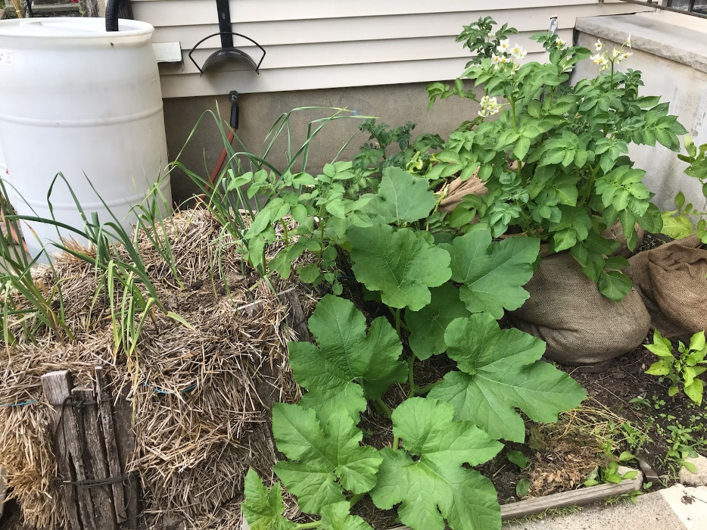
Grab a lunch and join Horticultural Program Assistant, Lynn Waclawski, for an informative presentation to educate and inspire individuals interested in growing a vegetable garden this year. Don’t have the space or want to try gardening before you commit? Straw bale gardening will also be discussed and may be fitting for you!

When: Monday, February 27th at 12:00 p.m.
Where: Virtually on Zoom
Registration: Free, but must pre-register by 2/23
https://go.rutgers.edu/85v2dau2

For more information call 908-475-6507

