Succulent Plant and Sip Night
Bring a friend, your favorite snack, and a beverage for a relaxing night out. Learn about succulents and their care, then plant and decorate your own.
All supplies included for $25 per person, adults over the age of 21 only please. Kitchenware not provided. Reserve your spot by 6/7/23, space is limited.
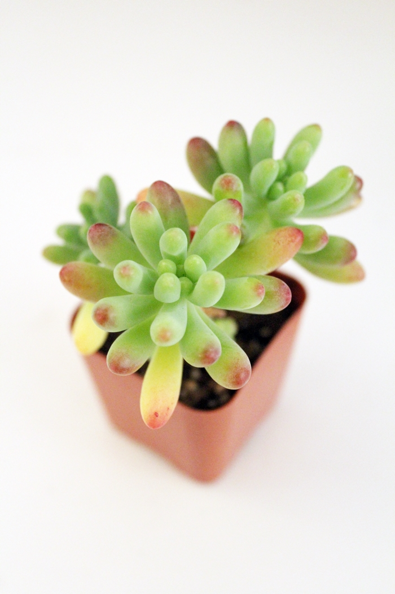

Where: Hope Community Center
5 Walnut Street, Hope, NJ

When: Saturday, 6/17/2023
7-9 PM

Register: go.rutgers.edu/7ib0u671

For more information call 908-475-6507
or
Email: lwaclawski@co.warren.nj.us

No gardening experience necessary, don’t miss this opportunity for a unique night out!

