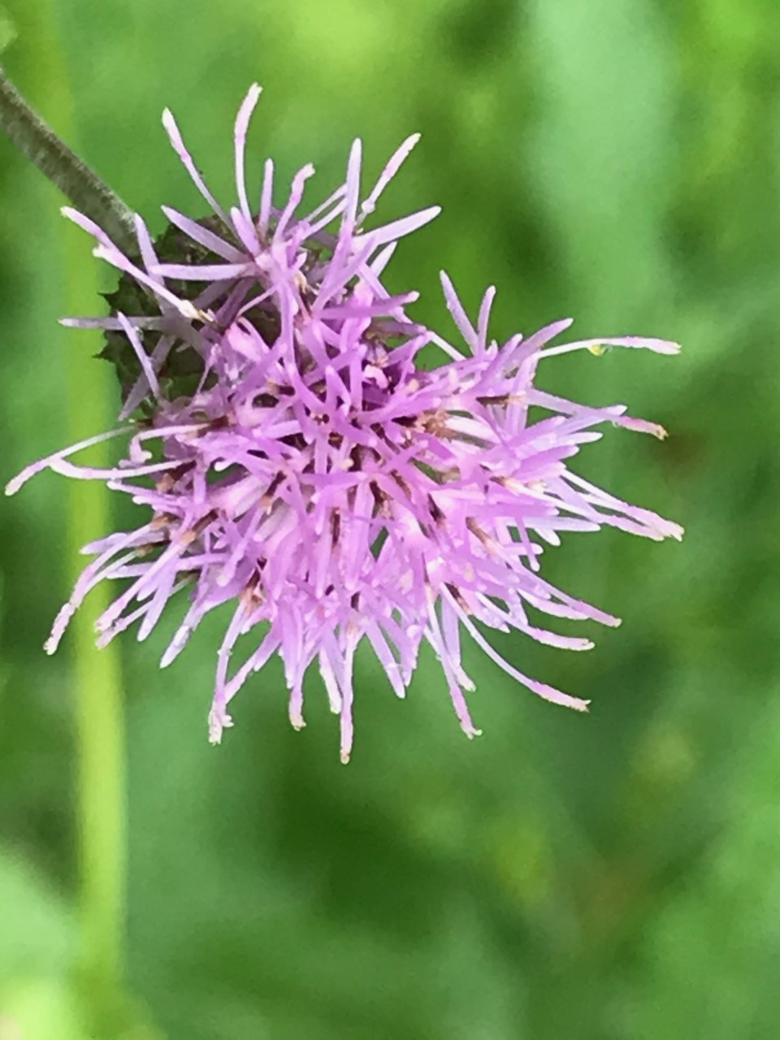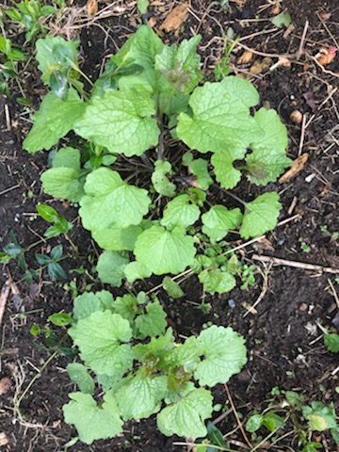  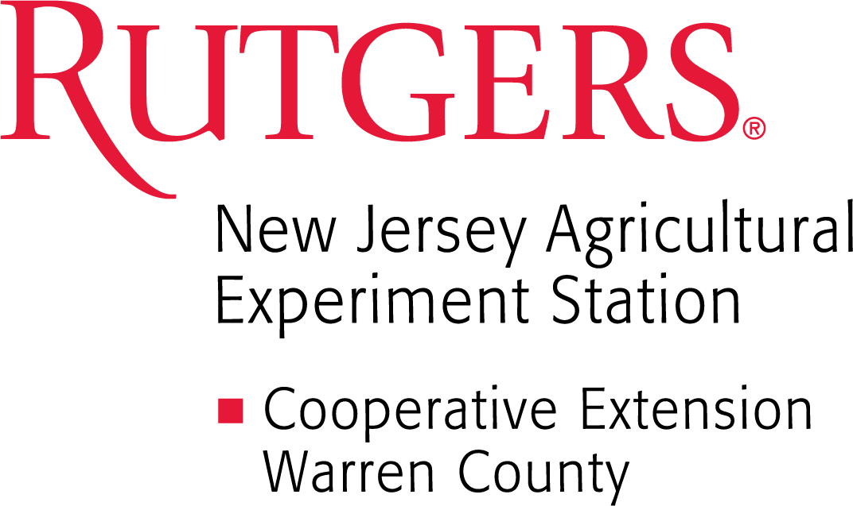  Plant this… not that  Learn about the problems with invasive weeds, how to identify them, and the benefits of replacing invasives with native plants. Three online presentations, with Lynn Waclawski and Lisa Chiariello, followed by an in-person pick up of a selection of native seedlings to plant at home! Pre-registration required, $25 pp. link: http://tinyurl.com/Plant-This (or scan the QR code)For more information call: 908-475-6507 or email lwaclawski@co.warren.nj.us | Invasive Weeds in NJ Part I  4/12/24 12-1PM  ______  Invasive Weeds in NJ Part II  4/19/24 12-1PM  ────  Native Plants 4/26/24 12-1 PM  ______  Plant Pick up Dates:  5/9-5/10 10-4 PM  RCE Office 165 CR-519 S Belvidere, NJ  ______  5/18 10-3 PM Agri-palooza Hoff VanNest Farmstead Harmony, NJ

